Subject: EDCI 2025 in Review!
Hello,
Welcome to our final newsletter of 2025! We’d like to begin by wishing you a happy holiday season and a wonderful start to the new year. We are grateful for all the progress we’ve made this year and look forward to continuing to work in pursuit of the EDCI’s mission in 2026.
2025 Recap | A year of significant progress for the initiative
In 2025 the EDCI made strong, continued progress toward its mission of driving convergence around meaningful sustainability metrics for the private markets and generating useful, comparable, performance-based data. A few highlights from this year include:
✨ More than 500 private markets GPs and LPs (spanning private equity, private credit, and infrastructure) are now committed members of the initiative, contributing to a benchmark that includes over 230,000 data points from more than 9,000 portfolio companies
📘BCG released its 2025 “Sustainability in Private Markets” report, highlighting how privately held companies are driving sustainable value creation across diverse contexts
🤝 The EDCI hosted working groups on Cybersecurity and Commercial Outcomes
- The Cybersecurity group led to a new optional metric being added for the 2026 cycle focused on cybersecurity testing
- The Commercial Outcomes group (our most attended to date, with ~70 members) developed draft methodologies linking EDCI outputs to commercial outcomes, which interested GPs can pilot in 2026, supported by a continuation of this working group
🔄 The GP-to-LP data-sharing feature has enabled GPs to fulfil 960 LP requests directly in the portal, with ~80% approved and ~90% of approved requests including portfolio company names, while the new due diligence tool enables investors to input sustainability data for potential new investments and instantly benchmark results against a customized peer-group
🌍 The EDCI held member events in New York, London, Sydney, Auckland, and Singapore to share key insights from the 2025 benchmark, along with a webinar for those members unable to join in person
💻 The EDCI added new technology platform collaborations, bringing the total to more than 25 platforms that support GP data submissions. Meanwhile, AssetMetrix, Dasseti, Gravity, Novata, and Pulsora are all formal tech platform partners of the initiative, offering integrated benchmark visualizations for their EDCI member clients
🧭 In light of the initiative’s extraordinary growth, the EDCI Steering Committee has decided to transition the initiative to a membership model for 2026 and beyond, ensuring a more sustainable foundation and enabling the initiative to continue to deliver its high-quality member experience
🗳️ The Steering Committee has also completed its latest round of elections and will be welcoming new members in 2026. Stay tuned for our first newsletter in January for more details

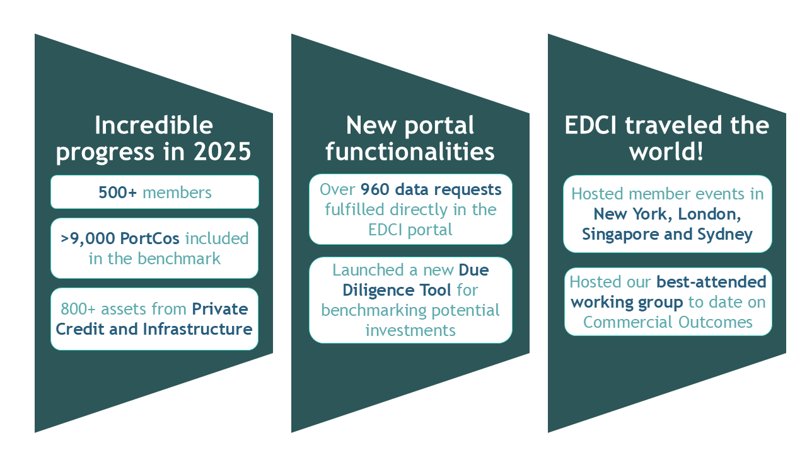

Please reach out to info@esgdc.org with any questions or to learn more about opportunities to participate in the EDCI in 2026.

Happy holidays!

-The EDCI Team

