FROM GPs to Portfolio Companies

We would like to inform you that on behalf of [insert your company name here], we have formally committed to the ESG Data Convergence Initiative (EDCI). We are very supportive of this initiative and expect it to have significant impact in driving ESG adoption and integration in the private equity industry. Further details on the initiative, why we participated and how this may impact you as a portfolio company are explained below.

What is the ESG Data Convergence Initiative?
The EDCI is an industry-led initiative which aims to streamline the private investment industry’s historically fragmented approach to collecting ESG data. This will help to converge ESG data reporting, while also creating a critical mass of meaningful, performance based, comparable ESG data from private companies. The EDCI will thereby allow General Partners (‘GPs’) and portfolio companies (‘PortCos’) to benchmark their current position and generate progress toward ESG improvements while enabling greater transparency and more comparable portfolio information for Limited Partners (‘LPs’).
It is important to note that the EDCI is not a new standard or framework. Rather, the initiative draws upon existing major frameworks. Since its launch in fall 2021, over 260 GPs and LPs have joined the initiative, representing ~$25 trillion USD in AUM and ~2000 underlying portfolio companies¹. ²

Why did we join the EDCI?
Our fund joined the EDCI in order to:
- Streamline reporting: Joining the EDCI will hopefully decrease the reporting burden we face as a GP, given the importance of standardizing definitions around key ESG metrics. This should translate into more standardized and predictable ESG information requests from us to you.
- Better support our PortCos: The EDCI benchmark allows us to compare our PortCos relative to industry peers (both public & private) on these key ESG metrics. This will help us gauge which PortCos can best benefit from our support on ESG performance through data & analytics and help us to ensure they are competitively well positioned (alongside helping them meet public market expectations ahead of a potential IPO).

How will our participation in the EDCI impact you?
Participating GPs of the EDCI collect and share data on a standardized set of metrics across six categories (aligned with existing ESG frameworks) shown below, with a central data aggregator:
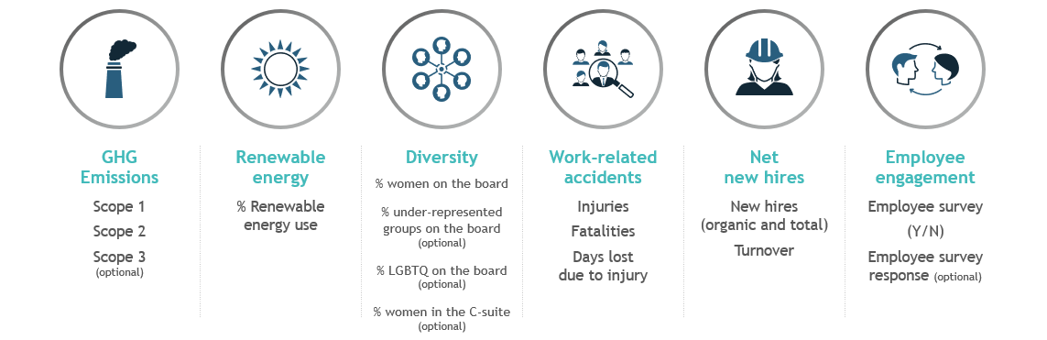
This means that we will be systematically looking to gather these data points going forward. This request should replace some of the metrics we already ask for from you, and therefore is not expected to increase your reporting burden. For more details on the exact metrics that we will report on in the upcoming years, please click here. Please do let us know if you have any questions. The EDCI assures confidentiality and security of the data submitted (see the Data Security section on the FAQs page).
You can find more information on the initiative here. You can also reach out to us with any questions you may have.

1 As of January 2023

