FROM LPs TO GPs

We would like to inform you that on behalf of [insert your company name here], we have formally committed to the ESG Data Convergence Initiative (EDCI). We are very supportive of this initiative and expect it to have significant impact in driving ESG adoption and integration in the private equity industry. Further details on the initiative, why we participated and how you can also get involved are explained below.

WHAT IS THE ESG DATA CONVERGENCE INITIATIVE?
The EDCI is an industry-led initiative which aims to streamline the private investment industry’s historically fragmented approach to collecting ESG data. This will help to converge ESG data reporting while also creating a critical mass of meaningful, performance-based, comparable ESG data from private companies. The EDCI will thereby allow General Partners (‘GPs’) and portfolio companies (‘PortCos’) to benchmark their current position and generate progress toward ESG improvements while enabling greater transparency and more comparable portfolio information for Limited Partners (‘LPs’).
Since its launch in fall 2021, over 260 GPs and LPs have joined the initiative, representing ~$25 trillion USD in AUM and ~2000 underlying portfolio companies.
It is important to note that the EDCI is not a new standard or framework. Rather, the initiative draws upon existing major frameworks and includes ESG metrics spanning six categories:

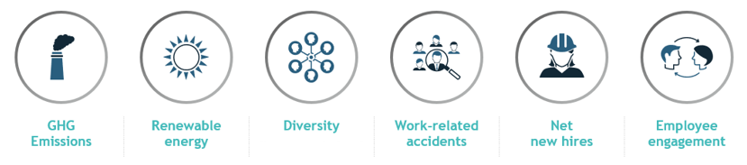

Why did we join the EDCI?
We are excited to have joined the EDCI as we expect it to address several pain points GPs and LPs collectively face:
- Streamlined reporting: By developing convergence around the definitions of key ESG metrics, we are looking forward to simplifying the current reporting burden on GPs and underlying portfolio companies.
- Increased transparency: We anticipate the EDCI will help provide us with greater transparency around the ESG performance of the investments we are making across our portfolio and allow us to undertake more informed investment allocation decisions.
- Facilitate opportunities for ESG-led value creation: Access to the benchmark will allow GPs to better understand how their portfolio companies compare to peers. This will help GPs gauge which PortCos can best benefit from support on ESG performance, helping to ensure they are competitively well positioned on sustainability topics (including ensuring they meet public market expectations ahead of a potential IPO).

How can you participate?
We would strongly encourage you to consider signing on as a member of the EDCI. Participating GPs commit to collecting and sharing data on a standardized set of six categories (aligned with existing ESG frameworks). Upon contributing data, you will be able to access the EDCI ESG benchmark and understand how your funds’ portfolio compares to this using a customized dashboard to enable easy comparisons.

The EDCI assures confidentiality and security of the data submitted (see the Data Security section on the FAQs page). Note that PortCo data is submitted by GPs on an anonymized basis and the benchmark will only be available to EDCI participants in an anonymized and aggregated form.

You can find more information on the initiative at the EDCI website and join here, at no cost for participation. You can also reach out to info@esgdc.org in case of further questions.

As of January 2023

