FROM Investment Consultants TO LPs
We would like to inform you that on behalf of [insert your company name here], we have formally committed to the ESG Data Convergence Initiative (EDCI). We are very supportive of this initiative and expect it to have significant impact in driving ESG adoption and integration in the private equity industry. Further details on the initiative, why we participated and how you can also get involved are explained below.

WHAT IS THE ESG DATA CONVERGENCE INITIATIVE?
The EDCI is an industry-led initiative which aims to streamline the private investment industry’s historically fragmented approach to collecting ESG data. This will help to converge ESG data reporting, while also creating a critical mass of meaningful, performance based, comparable ESG data from private companies. The EDCI will thereby allow General Partners (‘GPs’) and portfolio companies (‘PortCos’) to benchmark their current position and generate progress toward ESG improvements while enabling greater transparency and more comparable portfolio information for Limited Partners (‘LPs’).
Since its launch in fall 2021, over 260 GPs and LPs have joined the initiative, representing ~$25 trillion USD in AUM and ~2000 underlying portfolio companies.
It is important to note that the EDCI is not a new standard or framework. Rather, the initiative draws upon existing major frameworks and includes ESG metrics spanning six categories:

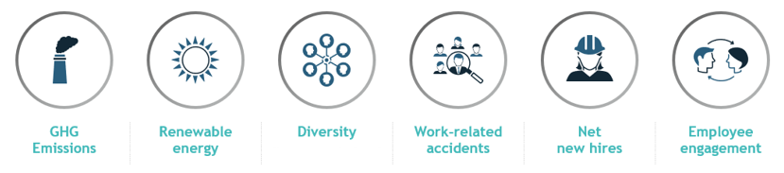Why did we join the EDCI?
We are excited to have joined the EDCI for the following reasons:
- Better support our LP clients: By joining the EDCI, we will be able to collaborate with our EDCI member LP clients to help them effectively draw on benchmark insights to make progress on ESG topics. Access to the aggregate benchmark will enhance our understanding of the ESG landscape in private markets and provide additional data to inform investment and portfolio recommendations (Please note that we are only able to utilize the EDCI benchmark data in our conversations with and recommendations for EDCI member LPs).
- Making progress on ESG topics: Beyond the ability to inform recommendations for our LP clients, we believe that the EDCI has the potential to create large-scale and long-term change on important ESG topics. Our participation in the initiative reflects our commitment to helping create a more sustainable future.

How can you participate?
We would strongly encourage you to consider signing on as a member of the EDCI. It is important to note that we are unable to utilize EDCI benchmark data with non-EDCI member LPs. Participating LPs receive access to the benchmark data collected by GPs upon committing to publicly support the project, and we will be able to advise member LPs on how the aggregate benchmark can be used to inform investment and portfolio decisions.
As a member of the initiative, LPs also commit to utilizing the EDCI’s definitions in ESG data requests to GPs. Participating LPs will not be required to submit data. Confidentiality and security of GP-submitted data is assured by the EDCI (see the Data Security section on the FAQs page).
You can find more information on the initiative at the EDCI website and join here, at no cost for participation. You can also reach out to info@esgdc.org in case of further questions.

As of January 2023

