FROM GPs TO LPs

We would like to inform you that on behalf of [insert your company name here], we have formally committed to the ESG Data Convergence Initiative (EDCI). We are very supportive of this initiative and expect it to have significant impact in driving ESG adoption and integration in the private equity industry. Further details on the initiative, why we participated and how you can also get involved as our LP are explained below.

What is the ESG Data Convergence Initiative?
The EDCI is an industry-led initiative which aims to streamline the private investment industry’s historically fragmented approach to collecting ESG data. This will help to converge ESG data reporting while also creating a critical mass of meaningful, performance based, comparable ESG data from private companies. The EDCI will thereby allow General Partners (‘GPs’) and portfolio companies (‘PortCos’) to benchmark their current position and generate progress toward ESG improvements while enabling greater transparency and more comparable portfolio information for Limited Partners (‘LPs’).
It is important to note that the EDCI is not a new standard or framework. Rather, the initiative draws upon existing major frameworks and includes ESG metrics spanning six categories:
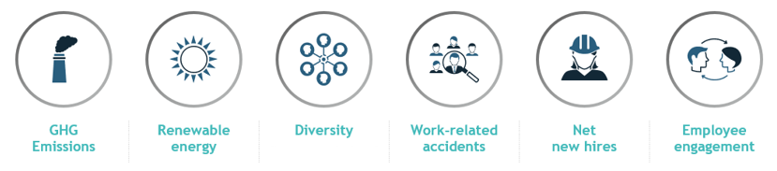

Since its launch in fall 2021, over 260 GPs and LPs have joined the initiative, representing ~$25 trillion USD in AUM and ~2000 underlying portfolio companies.

Why did we join the EDCI?
We are excited to have joined the EDCI as we expect it to address several pain points GPs and LPs collectively face:
- Streamlined reporting: By developing convergence around the definitions of key ESG metrics, we are looking forward to standardizing the information LPs request from their GPs, many of whom have likely already joined the initiative.
- Facilitate opportunities for ESG-led value creation: Access to the benchmark will allow us to better understand how our portfolio companies compare to peers. This will help us gauge which PortCos can best benefit from support on ESG performance, helping to ensure they are competitively well positioned on sustainability topics (including ensuring they meet public market expectations ahead of a potential IPO).

How can you participate?
We would strongly encourage you to consider signing on as a member of the EDCI. Participating LPs receive access to the aggregated benchmark data submitted by GPs upon committing to publicly support the project. As a member of the initiative, LPs also commit to utilizing the EDCI’s definitions in ESG data requests to GPs.
Participating LPs will not be required to submit data. Confidentiality and security of GP-submitted data is assured by the EDCI (see the Data Security section on the FAQs page). As a participating GP, we aim to submit data not only to the EDCI benchmark, but also to our LPs.
You can find more information on the initiative at the EDCI website and join here, at no cost for participation. You can also reach out to info@esgdc.org in case of further questions.

As of January 2023

